Title (Arial, 14 pt, centralized)

Author,¹ Author^{1,2} (Times New Roman, 12pt, centralized, underline the presenter)
¹ Department of AAA, BBB University, Country
²Institute of CCC, Country (Times New Roman, 12pt, centralized, italic)
1. Introduction (Section title: Times New Roman, 12 pt, bold)
Main text (Times New Roman, 12pt).
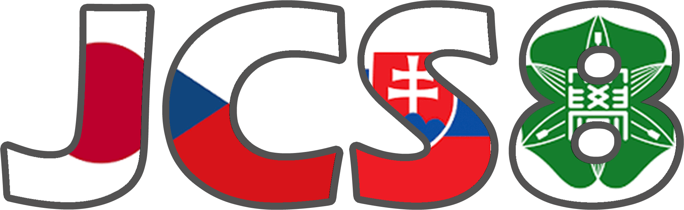
The JCS symposium (Figure 1) was initiated by Profs. R. Zahradnik, Z. Havlas, and H. Nakatsuji in 2004 based on the high-level scientific relationship and warm friendship between Japanese and Czech theoretical chemists [1]. The organizing policy of the JCS symposium is, "Friendship is our principle. Science will follow with us". Through the series of the trilateral symposium, theoretical chemistry communities in the three countries have been deepening our friendship and understanding on our science.
Figure 1. The logo mark of JCS8.

2. Method (section title names are arbitrary)

3. Additional notes
The abstract should not exceed one page.
Please convert your abstract file to the PDF format when you submit it.

References
[1] Authors, journal., vol, page-page (year).

